ABSTRACT

A great challenge in the biomedical engineering is the non-invasive assessment of the physiological changes occurring inside the human body. Specifically, detecting the abnormalities in the human eye is extremely difficult due to the various complexities associated with the process. Retinal images captured by digital cameras can be used to identify the nature of the abnormalities affecting the human eye. Conventional disease identification techniques from retinal images are mostly dependent on manual intervention. Human observation is highly prone to error, the success rate of these techniques is quite low. Diabetic Retinopathy is one such disease of retina which occurs in people suffering from long standing diabetes. It is a multistage progressing disease namely NDPR and PDR. Microaneurysms, haemorrhages and exudates are the abnormal features commonly observed in the retinal image of a person affected by diabetic retinopathy. Image processing techniques are used to pre-process the fundus image, which is followed by segmentation of anomalies. Feature extraction is done and the detected features are used to classify the different stages of diabetic retinopathy. The classification technique used is Random Forest, and the accuracy obtained is 89.9 %.

ii

CONTENTS

TITLE PAGE NO

ACKNOWLEDGEMENT i

ABSTRACT ii
LIST OF FIGURES v
LIST OF TABLES viii
- INTRODUCTION 1
  - Overview 1
  - Motivation 3
  - Problem Statement 4
- LITERATURE SURVEY 5
  - Technical Papers 5
- REQUIREMENT ANALYSIS 10
  - Feasibility study 10
  - System Requirements 12
  - Software Requirements 12
  - Hardware Requirements 12
- SYSTEM ANALYSIS AND DESIGN 13
  - Existing system 13
  - Proposed system 13
  - Data flow diagram 14
- IMPLEMENTATION 25
  - Algorithms 25
    - Proposed algorithm 25
    - Otsu thresholding algorithm 26
    - Random Forest algorithm 27
  - Methods 28
    - Structuring Element 28
    - Morphological operations 28
- TESTING 48
  - Introduction 48
  - Test cases 50
- SNAPSHOTS AND RESULTS 55
  - Snapshots 55
  - Results 59
CONCLUSION 60

BIBLIOGRAPHY

LIST OF FIGURES

FIGURE NO DESCRIPTION PAGE NO

Figure 1.1 Vision Affected by Diabetic Retinopathy. a. Normal
Vision and b. Vision affected by Diabetic Retinopathy 1
Figure 1.2 Fundu | s image with abnormalities | 2
Figure 4.1 System architecture |  | 14
Figure 4.2 Level | 0 DFD | 15
Figure 4.3 Level | 1 of DFD | 15
Figure 4.4 Level | 1.1 (pre-processing) DFD | 17
Figure 4.5 Red, Blue and Green channel images |  | 18
Figure 4.6 Level | 1.2 (Segmentation) DFD | 19
Figure 4.7 Input i | mage and the generated mask | 20
Figure 4.8 Level | 1.3 (Feature extraction) DFD | 22

Figure 4.9 Construction of GLCM 23

Figure 4.10 Level 1.4 (Classification) DFD 23

Figure 5.1a Original image 29

Figure 5.1b Image after dilation with disk shaped SE 29

Figure 5.2a Original image 30

Figure 5.3a | Opening operation with disk shaped image | 31
Figure 5.3b | Closing operation with disk shaped SE image | 31

Figure 5.4a Original image 32
Figure 5.4b Canny edge detected image 32
Figure 5.5a Illustration of a 3 x 3 median filter 32

Figure 5.5b Original image (left) and image after median filtering
(right) 33
Figure 5.6 GLCM calculation | 34
Figure 6.1 Case 1 actual output for Moderate severity level 50
Figure 6.2 Case 2 actual output for Normal Image 51
Figure 6.3 Case 3 actual output for Moderate severity level 52
Figure 6.4 Case 4 actual output for Moderate severity level 53
Figure 6.5 Case 5 actual output for Moderate severity level 54

Figure 7.1 First view of GUI 55
Figure 7.2 Database of Fundus images 56
Figure 7.3 Image is loaded from database 56
Figure 7.4 Error message if image is not choosen 57
Figure 7.5 Progress bar for grading the image 57

Figure 7.7 Help pop-up for users 58
Figure 7.8 Accuracy and other performance measures 59

LIST OF TABLES

TABLE NO DESCRIPTION PAGE NO

Table 5.1 Rules for dilation and erosion 29

Table 5.2 Function descriptions 35

Table 6.1 Test case 1 – best case 50

Table 6.2 Test case 2 – worst case 51

Table 6.3 Test case 3 – Not working case 52

Table 6.4 Test case 4 – Misclassified image 53

Table 6.5 Test case 5 – FOV 0° 54

CHAPTER 1

INTRODUCTION

OVERVIEW

Diabetic Retinopathy (DR) is a complication of Diabetes which affects the eye. It is caused by damage to the blood vessels of the retina – the light-sensitive tissue at the back of the eye. At first, diabetic retinopathy may cause no symptoms or only mild vision problems. Eventually, it can cause blindness. It is one of the leading cause of blindness in the world. Around 80 percent of population having diabetes for more than 10 or more years has some stage of the disease. Almost two‑third of all Type 2 and almost all Type 1 diabetics are expected to develop DR over a period of time.

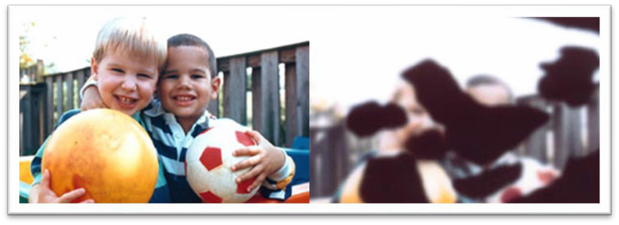

a b
Figure 1.1 Vision Affected by Diabetic Retinopathy. a. Normal Vision b. Vision affected by Diabetic Retinopathy

Figure 1.1 shows the difference between normal vision and diabetic retinopathy affected vision.
Diabetic retinopathy is classified into two types:

Non-proliferative diabetic retinopathy (NPDR) is the early stage of the disease in which symptoms will be mild or nonexistent. In NPDR, the blood vessels in the retina are weakened. Tiny bulges in the blood vessels, called microaneurysms, may leak fluid into the retina. This leakage may lead to swelling of the macula.

Proliferative diabetic retinopathy (PDR) is the more advanced form of the disease. At this stage, circulation problems deprive the retina of oxygen. As a result new, fragile blood vessels can begin to grow in the retina and into the vitreous, the gel-like fluid that fills the back of the eye. The new blood vessels may leak blood into the vitreous, clouding vision.
Other complications of PDR include detachment of the retina due to scar tissue formation. In PDR, new blood vessels grow into the area of the eye that drains fluid from the eye. This greatly raises the eye pressure, which damages the optic nerve. If left untreated, PDR can cause severe vision loss and even blindness.

Fundus Image
It is the image of the internal structure of the eye captured using specialized fundus cameras that consist of an intricate microscope attached to a flashed enabled camera. The main structures that can be visualized on a fundus image are the central and peripheral retina, optic disc and macula.

Retinal abnormalities
The common abnormalities found in the human retina are Microaneurysms, Haemorrhages and Exudates as shown in Figure 1.2.

Blood Vessels

Optic disc

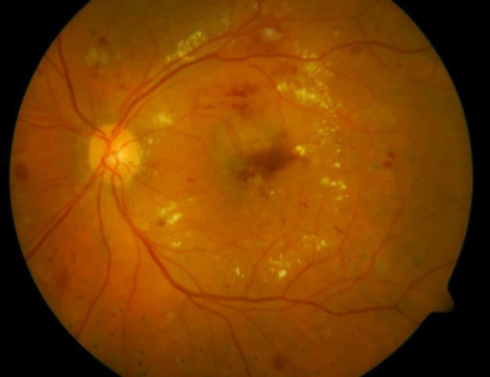Exudates Haemorrhages

Microaneurysm

Figure 1.2 Fundus image with abnormalities

Microaneurysms
A small swelling that forms on the ends of tiny blood vessels. These small swellings may break and allow blood to leak into nearby tissue. The earliest visibility of diabetic retinopathy is the microaneurysms.

Haemorrhages
Retinal hemorrhage is a disorder of the eye in which bleeding occurs into the retina. Retinal hemorrhages that take place outside of the macula if left undetected for many years, and may sometimes only be picked up when the eye is examined in detail by ophthalmoscopy or fundus photography. Some retinal hemorrhages can cause severe impairment of vision.

Exudates
As Diabetic Retinopathy progresses, a fluid rich in protein and cellular elements that oozes out of blood vessels due to inflammation and is deposited in nearby tissues. Exudates are manifested as spatially random yellowish or whitish patches of varying sizes, shapes and locations. These are the visible sign of DR and a major cause of visual loss in Non- Proliferative forms of DR.

  - MOTIVATION
Diabetic Retinopathy has become one of the leading causes of blindness, but it can be cured if diagnosed at an early stage, this requires regular eye examinations. Currently the examinations are done by ophthalmologists or optometrists manually. People from low income backgrounds and rural areas may not be able to afford these regular checkups. Setting up mass screening centers with automated systems can eliminate unnecessary visits to the ophthalmologist. This will also eliminate human intervention and thus reduce the cost.
The automated system will grade the images on the level of severity and refer only those patients who need medical attention to the Ophthalmologist. This will also relieve the burden on the doctor who would otherwise have to go through a lot of images which will come from the mass screening camps.

1.3 PROBLEM STATEMENT
Diabetes effects the circulatory system of a person, including that of the retina, which leads to DR. The oxygen supply to the visual system is reduced to a huge extent and it causes swellings on the retinal vessels. Also retinal lesions are formed which includes haemorrhages, microaneurysms and exudates. These are the symptoms for the disease, which will not be visible in the initial stages of the disease. Therefore, unless the patient takes regular examination of the disease, it cannot be identified and thus not cured.

For a given collection of retinal fundus images (1…N), where N is greater than 100,
the purpose is:

- Precise classification of input images into normal, mild, moderate, severe.

- To increase classification accuracy and analyze the efficiency of the proposed work with the existing algorithms.

CHAPTER 2

LITERATURE SURVEY

2.1 TECHNICAL PAPERS

Image Processing for Identifying Different Stages of Diabetic Retinopathy [1].
In this work, an algorithm has been developed for the identification of the different stages of Diabetic Retinopathy (DR). The irregularities in the retinal blood vessels such as changes in the perimeter, area of spread are considered as a measure of severity of DR. The input fundus images are obtained from the MESSIDOR Database. A total of 100 images are analyzed in the present study. These images are graded into four sub sets as Grade 0, 1, 2 and 3. Grade 0 corresponds to normal retinal images or no DR. Grade 1 images correspond to Mild Non-Proliferative Retinopathy. Grade 2 images correspond to Moderate and Severe Non-Proliferative Retinopathy. Grade 3 images correspond to Proliferative Retinopathy. This algorithm provides 85% accuracy.
Segmentation Method: Edge detection is a fundamental tool in image processing, in the areas of feature detection and feature extraction. The result of applying an edge detector to an image leads to a set of connected curves that indicate the boundaries of objects, the boundaries of surface markings as well as curves that correspond to discontinuities in surface orientation. Thus, applying an edge detection algorithm to a retinal image significantly extract the blood vessels. For edge detection technique the non-linear Sobel filter is employed. A nonlinear filter replaces each pixel value with a nonlinear function of its surrounding pixels. Like the linear filters, the nonlinear filters operate on a neighborhood. The nonlinear Sobel filter is a highpass filter that extracts the outer contours of objects. It highlights significant variations of the light intensity along the vertical and horizontal axes.
Machine Learning (ML) Model: No ML model has been used here, the fundus images are classified in to grades based on the perimeter and area values of the blood vessels.

BP and SVM based Diagnosis of Diabetic Retinopathy [2].
This work proposes an algorithm for identification of the different stages of diabetic retinopathy. The early signs of DR Microaneurysms are considered for classifying the different stages of the disease. The input fundus image is pre-processed using median filter to remove salt and pepper noise. MAs look like isolated patterns and are detached from the vessels. Based on the shape, intensity level and size the features of Microaneurysms can be extracted. After the detection of Microaneurysms, Depending on the count of detected Microaneurysms, the images are classified whether it is normal, mild moderate and severe by using SVM. This method provides 83% accuracy, 74% sensitivity and 100% specificity.
Segmentation Method: MAs look like an isolated pattern and are detached from the vessels. Based on the shape, intensity level and size the features of Microaneurysms can be extracted. As soon as image is pre-processed, the candidates Microaneurysms are segmented through isolating them from veins. Blood vessels are huge in subject and are related section, hence can recognize from MA situated on area. By the experimentation the threshold value is chosen to remove blood vessels. The threshold value are eliminated if the object has greater area. For the experimentation, two threshold values are chosen to cast off noise objects having greater area and scale down than MAs. The consequential image having objects which have the identical region and some of them are MAs. MAs are identified from the noises which are in irregular shape. The noise having same area as Microaneurysms are removed based on the major and minor axis. Based on perimeter and circularity the Microaneurysms are detected. Based on the resultant image from the previous segment the canny edge detection is performed. Each perimeter and object area is manipulated and these outcomes are utilized to form a simple metric representing the roundness of an entity.
ML Model: SVM training approach is utilized to compare coaching information to discover a fine viable way to categories the DR images into their respective categories, natural, slight, moderate and severe. It is robust procedure for the categorization of information and deterioration. It appears for a hyper plane that may linearly separate courses of objects. It looks for a hyper plane that can linearly separate classes of items. This technique is utilized to recognize the different classes. It is used to differentiate the various categories.

Diabetic Retinopathy: Patient Identification and Measurement of the Disease Using ANN [3].
In this system, fundus retinal image is used to diagnose diabetic retinopathy patient. Developed system used green plane out of RGB component of image due more clarity. Green plane is selected because red planes have saturated features and blue plane has low intensity features while contours are easily viewed in green plane due to proper intensity features. Median filtering operation and histogram equalization operations is performing on a green plane to analyze various features in DR patient. In the given system defects boundaries are created around the affected areas of the retina image and calculating the areas. According to the area of DR feature component and with the help ANN by training and defining weights to the previous layer. Severity of the disease can be analyzed. Achieved an accuracy of 86.36%.
Segmentation Method: Morphological operation like closing and opening (Dilation or Erosion) is required to identify feature accurately with the help of threshold value for Defects. Besides that Hough transform is used to isolate the features of the particular shape within an image. In the given system defects boundaries are created around the affected areas of the retina image and calculates the areas.
ML Model: Artificial Neural Networks are relatively crude electronic models based on the neural structure of the brain. ANN is also called perceptron. Single layer perceptrons are used to classify linear data, by introducing additional hidden layers non-linear data can be classified. A multilayered perceptron is used with one input layer, one hidden layer and one output layer is being used. According to the area of DR feature component and with the help Artificial Neural Network (ANN) by training and defining weights to the previous layer. Severity of the disease can be classified.

Diabetic Retinopathy Detection using Random Forest [4].
This system proposes classification of fundus images using random forest algorithm. From the total 778 images 287 features are extracted. After extraction classes are formed as class 0, class 1, class 2, class 3 having 360, 88, 142, 188 respectively. The Random Forests algorithm is one of the best among classification algorithms - able to classify large amounts of data with accuracy. Random Forests are an ensemble learning method for classification and regression that construct a number of decision trees at training time and outputting the class that is the mode of the classes output by individual trees where each tree depends on the values of a random vector sampled independently with the same distribution for all trees in the forest. The basic principle is that a group of “weak learners” can come together to form a “strong learner”. Achieved an accuracy of 74.93%.
Segmentation Method: No segmentation (Huge feature set is extracted), for feature extraction MaZda software is used. MaZda load images in the form of Windows Bitmap, DICOM and unformatted grey-scale image files with pixels intensity encoded with 8 or 16 bits. Additionally, there is an option for reading details of image acquisition protocol extracted from the image information header. Image normalization. Defining regions of interest (ROI), then analysis is performed within these regions. Up to 16 regions of any shape can be defined; they can be also edited, loaded and saved as disk files. The feature set is divided into following groups: histogram-, co-occurrence matrix-, run-length matrix-
, gradient, autoregressive model- and Haar wavelet derived features. Displaying image analysis reports, saving and loading reports into disk files.

ML Model: The Random Forests algorithm is one of the best among classification algorithms - able to classify large amounts of data with accuracy. Random Forests are an ensemble learning method for classification and regression that construct a number of decision trees at training time and outputting the class that is the mode of the classes output by individual trees. The basic principle is that a group of “weak learners” can come together to form a “strong learner”. Random Forests are a wonderful tool for making predictions considering they do not over-fit because of the law of large numbers. Introducing the right kind of randomness makes them accurate classifier.

Automatic Detection of Microaneurysms and Classification of Diabetic Retinopathy Images using SVM Technique [5].
The main objective of this work is to detect the early stage of DR using the features extracted from the pre-processed image. The image obtained from the database is subjected to the pre-processing steps such as green channel extraction, contrast enhancement, median filtering and histogram equalization. After pre-processing, the image is morphologically operated by a disk shaped structuring element. Connected component analysis method is used for the removal of optic disk. This image is then utilized for feature extraction. The features like Microaneurysms area, homogeneity and texture properties are extracted. The appropriate features for classification are selected. Support Vector Machine technique is used for classifying the input images as normal and DR based image as well as detecting the earlier stage of DR using the extracted features.
Segmentation Method: The pre-processed image is converted to binary image by applying proper thresholding value. This binary image is subjected to morphological operations i.e. opening and closing. Closing operation is defined as dilation and opening as erosion. Dilation is an operation that grows or thickens objects in a binary image. Erosion shrinks or thins the objects in the binary image. Structuring element is defined as the shape (dimension) that controls the process of thickening and thinning. As the optic disk and microaneurysms are circular in shape, a disk shape structuring element is used in this project and the optic disk occupies more area of the retinal image and it should be removed for facilitating the microaneurysms detection. Thus the connected component analysis method is used for the elimination of optic disk.
ML Model: Support Vector Machine Support vector machine is a supervised learning process applied for analyzing the training data to find an optimal way to classify the diabetic retinopathy images into their respective classes namely Normal, Mild and Severe. SVM is a robust method used for data classification and regression. SVM models constructs a hyperplane for separating the given data linearly into separate classes. The training data should be statistically sufficient. The classification parameters are formed according to the calculate features using the SVM algorithm. These classification parameters are used for classifying the images.

CHAPTER 3

REQUIREMENT ANALYSIS

FEASIBILITY STUDY

A feasibility study is carried out to select the best system that meets performance requirements. The main aim of the feasibility study activity is to determine whether it would be financially and technically feasible to develop the product. The feasibility study activity involves the analysis of the problem and collection of all relevant information relating to the product such as the different data items which would be input to the system, the processing required to be carried out on these data, the output data required to be produced by the system as well as various constraints on the behavior of the system. The key objective of the feasibility study is to weigh up three types of feasibility. They are:
    - Operational Feasibility
    - Technical Feasibility
    - Economic Feasibility

- Operational Feasibility:
This is mainly related to human organizational and political aspects. The points to be considered are:
  - What new skills will be required? Do the existing staff members have these skills? If not, can they be trained in due course of time?
  - What changes will be brought with the system?
The proposed system will provide an automated system for the detection of the disease.
The technicians will have to learn how to feed the images to the system.
- Technical Feasibility:
Technical feasibility analysis makes a comparison between the level of technology available and that is needed for the development of the project. The level of technology

consists of the factors like software tools, machine environment, and platform developed and so on. It is also concerned with specifying equipment and software that will successfully satisfy the user requirement. The technical needs of the system may vary considerably.

- Economic Feasibility:
This is the most important part of the project because the terms and conditions for implementing the project have to be economically feasible. The risk of finance does not exist as the existing hardware is sufficient and the software is free of cost. The system is economically feasible.

Hardware Interface:
Describes the logical and physical characteristics of each interface between the software product and the hardware components of the system. This may include the supported device types, the nature of the data and control interactions between the software and the hardware, communication protocols to be used.

Software Interface:
Describes the connections between this product and other specific software components (name and version), including databases, operating systems, tools, libraries, and integrated commercial components. Identify the data items or messages coming into the system and going out and describe the purpose of each. Describe the services needed and the nature of communications.

Objective of Software Project Planning

The objective of software project planning is to provide a frame work that enables the reasonable estimation of resources, cost and schedule.

Software Scope

The first activity in software project planning is the determination of software scope. A software project scope must be unambiguous and understandable at the

management and technical levels. The software scope means the actual operation that is going to be carried out by the software and its plus points and limitations.

Resources

The second task of software planning is the estimation of resources required. Each resource is specified with the following characteristic. Resource descriptions, details of availability, when it is required, how long it is required.

- Human Resource
- Hardware Resource
- Software Resource

SYSTEM REQUIRMENTS

The system requirements are a listing of what software programs or hardware devices are required to operate the program properly.

SOFTWARE REQUIREMENTS

Tools : Anaconda IDE
Operating System : Windows 7 and above Java Version : JDK 7

HARDWARE REQUIREMENTS

Processor : Intel Core i5 Speed : 2.4 GHz
RAM : 4 GB
Hard Disk : 20 GB

CHAPTER 4

SYSTEM ANALYSIS AND DESIGN

EXISTING SYSTEM

All the existing systems are concentrating on segmenting the primary anomalies responsible for initial stage of the disease. Their proposed method is also database dependent and would work only for that specific database. There is no single approach or method for segmenting all the anomalies. Building an optimal feature set is needed as this disease is vision threatening and high benchmarking results need to be achieved. Many classification techniques are proposed with different and novel approaches of pre- processing. All these surveyed papers achieve an average of 85% accuracy which still need to be improved. Researches throughout the world are trying to propose better classification algorithms by building significant feature set. Limitations of the existing systems are defects that arise due to DR compliances which cannot be extracted using single method. Hence there is a need to developed system will overcome and able extract all features using single platform.

PROPOSED SYSTEM

The Proposed system is a multistage classifier of Diabetic Retinopathy. This system overcomes the drawbacks of the existing system by classifying the disease in to four stages, namely, Normal, NPDR 1, NPDR 2 and PDR. This multistage classification is important because the disease itself progresses in multiple stages. The reoccurrence of the disease depends on the stage in which the treatment is provide, so it is not enough to classify the image as normal and abnormal.
The pre-processing part of both the existing and proposed system remain similar, the difference comes in the segmentation and feature extraction stages. Existing system only segmented anomalies like microaneurysms, the problem with this is this anomaly

occurs in the initial stage of the disease. Treatment cannot be given at this stage, hence this is a major drawback. The proposed system overcomes this by segmenting haemorrhages along with microaneurysms and also by considering a large feature set which includes the area and count of the segmented anomalies. The feature set also includes textural features like energy and correlation, and statistical features like mean and variance. This feature set is then used to classify the image into the respective severity. Figure 4.1 shows the system architecture of the proposed system.


PRE- PROCESSING
Multiple-Anomalies

Figure 4.1 System architecture

DATA FLOW DIAGRAM
A data flow diagram (DFD) illustrates how data is processed by a system in terms of inputs and outputs. As its name indicates its focus is on the flow of information, where data comes from, where it goes and how it gets stored.
Applications of DFD

DFDs are a common way of modeling data flow for software development. For example, a DFD for a word-processing program might show the way the software processes the data that the user enters by pressing keys on the keyboard to produce the letters on the screen.

Significance of DFD

DFDs are popular for software design because the diagram makes the flow of data easy to understand and analyze. DFDs represent the functions a system performs hierarchically, starting with the highest-level functions and moving through various layers or levels of sub-functions. As a modeling technique, DFDs are useful for performing a structured analysis of software problems, allowing developers to spot and pinpoint issues in software development.
Every system is developed either to satisfy a need or to overcome the drawbacks of an existing system.

Level 0

Fundus Image

Detection and Classification
Severity Level

Figure 4.2 Level 0 DFD
Figure 4.2 shows the level 0 DFD. The fundus image of the eye is given as the input, the disease is detected and classified to give the severity level of the disease i.e. grades 0,1,2,3 corresponding to normal, mild, moderate and sever.

Level 1

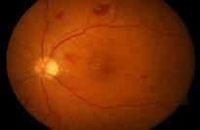
Grade (0, 1, 2, 3)
1.1

Pre-Processing
1.2
Segmentation
Fundus image
1.4
Classification
1.3
Feature Extraction

Figure 4.3 Level 1 of DFD

Each fundus image fed into the system undergoes a series of processes as shown in Figure 4.3, they are:

Pre-processing:

Patient movement, poor focus, bad positioning, reflections, inadequate illumination can cause a significant proportion of images to be of such poor quality as to interfere with analysis. In approximately 10% of the retinal images, artifacts are significant enough to impede human grading. Preprocessing of such images can ensure adequate level of success in the automated abnormality detection. In the retinal images there can be variations caused by the factors including differences in cameras, illumination, acquisition angle and retinal pigmentation. First step in the preprocessing is to attenuate such image variations by normalizing the color of the original retinal image against a reference image. Few of the retinal images acquired using standard clinical protocols often exhibit low contrast. Also, retinal images typically have a higher contrast in the center of the image with reduced contrast moving outward from the center. For such images, a local contrast enhancement method is applied as a second preprocessing step.

Segmentation:

Involves the partitioning of an image or volume into Involves the partitioning of an image or volume into distinct (usually) non-overlapping regions in a meaningful way.
Segmentation-

- Identifies separate objects within an image Identifies separate objects within an image.

  - Finds regions of connected pixels with similar properties.

  - Finds boundaries between regions.

- Removes unwanted regions.

Feature Extraction:

Feature extraction a type of dimensionality reduction that efficiently represents interesting parts of an image as a compact feature vector. This approach is useful when

image sizes are large and a reduced feature representation is required to quickly complete tasks such as image matching, classification and retrieval.

Classification:

Image classification analyzes the numerical properties of various image features and organizes data into categories. Classification algorithms typically employ two phases of processing: training and testing. In the initial training phase, characteristic properties of typical image features are isolated and, based on these, a unique description of each classification category, i.e. training class, is created. In the subsequent testing phase, these feature-space partitions are used to classify image features.

Level 1.1

Colour Fundus Image

RGB to green channel
Re-size
Median Filtering
CLAHE
Enhanced Image

Figure 4.4 Level 1.1 (pre-processing) DFD

Preprocessing stage as shown in Figure 4.4 includes the following sub stages:

RGB to Green Channel:

The color image is converted to a gray scale image and then the green channel is extracted from it. Green channel is better than the red or blue channels because the red channel image is too bright and the blue channel image is too dark. All the anomalies are visible properly in the green channel image. A comparison of the images of the three channels is shown in Figure 4.5.

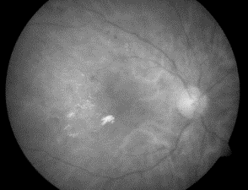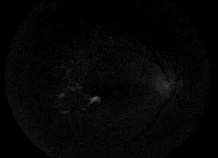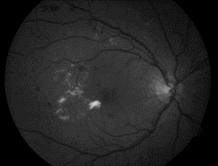

Figure 4.5 Red, Blue and Green channel images

Image resizing:

The green channel image is then resized to 560x720 Standard aspect ratio.

Median filtering:

One of the major advantages of pre-processing an image is to remove noise. Median filtering is one of the methods that is used for the same. Median filtering is a nonlinear method used to remove noise from images. It is widely used as it is very effective at removing noise while preserving edges. It is particularly effective at removing ‘salt and pepper’ type noise. The median filter works by moving through the image pixel by pixel, replacing each value with the median value of neighboring pixels. The pattern of neighbors is called the "window", which slides, pixel by pixel over the entire image 2 pixel, over the entire image. The median is calculated by first sorting all the pixel values from the window into numerical order, and then replacing the pixel being considered with the middle (median) pixel value.

CLAHE:

Contrast Limited Adaptive Histogram Equalization is one of the well-known enhancement techniques. In histogram equalization, the dynamic range and contrast of an image is modified by altering the image such that its intensity histogram has a desired shape. The intensity levels are changed such that the peaks of the histogram are stretched and the troughs are compressed. In contrast limited histogram equalization (CLHE), the histogram is cut at some threshold and then equalization is applied. Contrast limited adaptive histogram equalization (CLAHE) is an adaptive contrast histogram equalization method, where the contrast of an image is enhanced by applying CLHE on small data regions called tiles rather than the entire image. The output of this stage is an enhanced image.

Level 1.2

Pre-Processed Image
Mask
Generation
Vessel detection
and removal
Boundary detection
and removal
Microaneurysm
segmentation
Haemorrhage
Segmentation

Segmented Anomalies

Figure 4.6 Level 1.2 (Segmentation) DFD

The enhanced image obtained in the previous stage is then segmented. Segmentation involves the following sub stages:

Mask Generation:

The mask is a binary image with the same resolution as that of fundus image whose positive pixels correspond to the foreground area. It is important to separate the fundus from its background so that the further processing is only performed for the fundus and not interfered by pixels belonging to the background. In a fundus mask, pixels belonging to the fundus are marked with ones and the background of the fundus with zeros. The fundus can be easily separated from the background by converting the original fundus image from the RGB to HSI color system where a separate channel is used to represent the intensity values of the image. The intensity channel image is threshold by a low threshold value as the background pixels are typically significantly darker than the fundus pixels. A median filter is used to remove any noise from the created fundus mask and the edge pixels are removed by morphological erosion. The final mask obtained is shown in Figure 4.7.

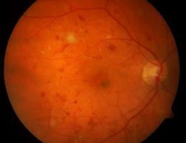

Figure 4.7 Input image and the generated mask Vessel detection and removal:
Blood vessel segmentation is a significant step in the red lesion detection. Since the blood vessels and red lesions namely microaneurysms and haemorrhages are both red in color the blood vessels need to be extracted out of the fundus image in order to effectively detect the microaneurysms and haemorrhages. A Contrast limited adaptive histogram equalization (CLAHE) is performed on the negative of green channel image. Top-hat filter operation is applied using a flat disc shaped structuring element. Top-hat filtering is the equivalent of subtracting the result of performing a morphological opening operation on

the input image from the input image itself. Suitable threshold is used to segment out the blood vessels. This threshold is selected based on the a priori knowledge of the quality of the image. The resultant image comprises of blood vessels along with haemorrhages, micro-aneurisms and other stray structures. After removing structures that have area less than a decided threshold the image containing only blood vessels is obtained.

Boundary detection and removal:

The boundary of the fundus image gets separated in the process of segmentation and has to be removed as it causes false detections. By using the generated mask the boundary is removed.

Microaneurysm and Haemorrhage Segmentation:

The microaneurysms and dot haemorrhages are Structures with sharp edges and circular in shape. Edge detection is done. The detected edges are then filled by applying morphological closing operation by using a flat disc shaped structuring element. The image obtained contains microaneurysms and Haemorrhages and blood vessels. Finally the blood vessels are subtracted from the image to get the red lesions. Microaneurysms and haemorrhages are further separated from each other depending on the difference in their sizes. Structures having area smaller than a threshold are classified as candidate microaneurysms. The candidate microaneurysms contain small fragments of blood vessels along with microaneurysms. Since these fragments are thin linear structures these are eliminated by applying a morphological opening operation with a disc shaped structuring element. Structures bigger than microaneurysms are classified as candidate haemorrhages. These also contains fragments of blood vessels which are eliminated by applying a morphological opening operation.

Level 1.3

Once the anomalies are segmented the next stage is feature extraction. The different features extracted are shown in Figure 4.8. The gray scale image of the input image is used to extract textural features and statistical features. The textural features are obtained by

using GLCM. Gray-Level Co-Occurrence Matrix is created by calculating how often a pixel with the intensity (gray- level) value i occurs in a specific spatial relationship to a pixel with the value j. By default, the spatial relationship is defined as the pixel of interest and the pixel to its immediate right (horizontally adjacent), but you can specify other spatial relationships between the two pixels. Each element (i, j) in the resultant glcm is simply the sum of the number of times that the pixel with value i occurred in the specified spatial relationship to a pixel with value j in the input image. The gray-level co-occurrence matrix can reveal certain properties about the spatial distribution of the gray levels in the texture image.

Feature Set
Green-Channel & Binary Image
Green-Channel
GLCM
Textural Features
Green-Channel
Statistical features
Binary Image Area, Count

Figure 4.8 Level 1.3 (Feature extraction) DFD

To illustrate, the Figure 4.9 shows how graycomatrix calculates the first three values in a GLCM. In the output GLCM, element (1,1) contains the value 1 because there is only one instance in the input image where two horizontally adjacent pixels have the values 1 and 1, respectively. glcm (1,2) contains the value 2 because there are two instances where two horizontally adjacent pixels have the values 1 and 2. Element (1,3) in the GLCM has the value 0 because there are no instances of two horizontally adjacent pixels with the values 1 and 3. graycomatrix continues processing the input image, scanning the image for other pixel pairs (i,j) and recording the sums in the corresponding elements of the GLCM. The statistical features are calculated by applying the respective formula. From the segmented anomalies the area and count are also calculated. The textural

features, statistical features and the area and count form the feature set. This is fed to the classifier in the next stage.

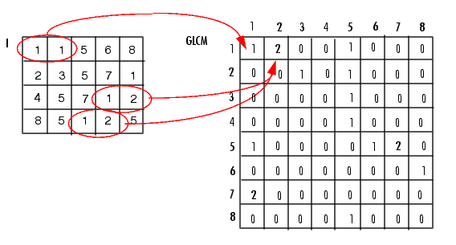

Figure 4.9 Construction of GLCM

Level 1.4

Training Feature Set

Grades (0,1,2,3)
*
Classifier
*

Figure 4.10 Level 1.4 (Classification) DFD

Testing Feature Set

Figure 4.10 shows the DFD for classification, training and testing data are both given as input to a classifier and the grade of severity is obtained as output.

Classification will be made according to the following procedure: Step 1: Definition of Classification Classes
Depending on the objective and the characteristics of the image data, the classification classes should be clearly defined.

Step 2: Selection of Features
The most significant features are selected from the huge feature set. Step 3: Sampling of Training Data

Training data should be sampled in order to determine appropriate decision rules. Classification techniques such as supervised or unsupervised learning will then be selected on the basis of the training data sets.

The proposed system uses supervised learning. Supervised learning is the machine learning task of inferring a function from labeled training data. The training data consist of a set of training examples. In supervised learning, each example is a pair consisting of an input object and a desired output value. A supervised learning algorithm analyzes the training data and produces an inferred function, which can be used for mapping new examples. An optimal scenario will allow for the algorithm to correctly determine the class labels for unseen instances.

Step 4: Estimation of Universal Statistics

Various classification techniques will be compared with the training data, so that an appropriate decision rule is selected for subsequent classification.

Step 5: Classification

Depending up on the decision rule, the images are classified into different classes. These classes represent the severity level of the disease and are represented by grades 0, 1, 2 and 3, where 0 is normal, 1 is mild, 2 is moderate and 3 is sever.

CHAPTER 5

IMPLEMENTATION

ALGORITHMS

Proposed algorithm

Input: Fundus image

Output: Grade of severity (0, 1, 2, 3)

Step 1: Input fundus image is retrieved from the test set Step 2: Green channel of the image is extracted
Step 3: The image is then passed through median filter Step 4: CLAHE is applied to the output of previous step
Step 5: The image is then resized to a standard size of 576*720

Step 6: Morphological operations are applied to extract microaneurysms and Haemorrhages

Step 7: Area and count of these anomalies are extracted as features. Statistical and GLCM features are also extracted

Step 8: The feature set extracted is then provided to the Random forest classifier for classification of severity levels.

Otsu thresholding algorithm

Otsu thresholding divides image into Foreground and Background Pixels, thus assigning Pixels nearer to the black level as 0 and white level as 1, converting image to binary. The thresholding identifies minimum variance between these pixels to aptly identify them.
Otsu's thresholding method involves iterating through all the possible threshold values and calculating a measure of spread for the pixel levels each side of the threshold,
i.e. the pixels that either fall in foreground or background. The aim is to find the threshold value where the sum of foreground and background spreads is at its minimum.
Otsu thresholding algorithm has the following steps:

Input: Pre-processed image

Output: Binary image

Step 1: Read a gray scale image. Step 2: Calculate image histogram.
Step 3: Select a threshold and referred as t,

  - Calculate foreground variance.

  - Calculate background variance. Step 4: Calculate Within-Class variance.
Step 5: Repeat steps 3 and 4 for all possible threshold value.

Step 6: Final global threshold, T = threshold in MIN (Within-class variance) Step 7: Binarize Image = gray scale image > T

5.1.3 Random Forest algorithm

The Random Forests algorithm is one of the best among classification algorithms - able to classify large amounts of data with accuracy. Random Forests are an ensemble learning method (also thought of as a form of nearest neighbor predictor) for classification and regression that construct a number of decision trees at training time and outputting the class that is the mode of the classes output by individual trees. Random Forests are a combination of tree predictors where each tree depends on the values of a random vector sampled independently with the same distribution for all trees in the forest. The basic principle is that a group of “weak learners” can come together to form a “strong learner”. Random Forests are a wonderful tool for making predictions considering they do not over fit because of the law of large numbers. Introducing the right kind of randomness makes them accurate classifiers and regressors. Single decision trees often have high variance or high bias. Random Forests attempts to mitigate the problems of high variance and high bias by averaging to find a natural balance between the two extremes. Considering that Random Forests have few parameters to tune and can be used simply with default parameter settings, they are a simple tool to use without having a model or to produce a reasonable model fast and efficiently.

Random Forests grows many classification trees. Each tree is grown as follows:
Input: Feature set
Output: Grade of severity

Step 1: If the number of cases in the training set is N, sample N cases at random - but with replacement, from the original data. This sample will be the training set for growing the tree.
Step 2: If there are M input variables, a number mM is specified such that at each node, m variables are selected at random out of the M and the best split on these m is used to split the node. The value of m is held.
Step 3: Constant during the forest growing.

Step 4: Each tree is grown to the largest extent possible. There is no pruning.

METHODS

Structuring Element
A structuring element (SE) is a binary morphology that is used to probe the image. It is a matrix consisting of only 0's and 1's that can have any arbitrary shape and size. The pixels with values of 1 define the neighborhood. There are two types of SE, two-dimensional or flat SE usually consists of origin, radius and approximation N value. Three-dimensional or non-flat SE usually consists of radius (x-y planes), height and approximation N value. There are different types of SE shapes but in this project, disk shaped, ball shaped and octagon shaped SE are used.

Morphological operations

Morphological operations are used to understand the structure or form of an image. This usually means identifying objects or boundaries within an image.
Morphological operations apply a structuring element to an input image, creating an output image of the same size. In a morphological operation, the value of each pixel in the output image is based on a comparison of the corresponding pixel in the input image with its neighbors. By choosing the size and shape of the neighborhood, a morphological operation can be created that is sensitive to specific shapes in the input image. There are many types of morphological operations such as dilation, erosion, opening and closing.

Dilation and Erosion

Dilation and erosion are basic morphological processing operations. They are defined in terms of more elementary set operations, but are employed as the basic elements of many algorithms. Both dilation and erosion are produced by the interaction of structuring element with a set of pixels of interest in the image.
Dilation adds pixels to the boundaries of objects in an image, while erosion removes pixels on object boundaries. The number of pixels added or removed from the objects in an image depends on the size and shape of the structuring element used to process the image. In the morphological dilation and erosion operations, the state of any given pixel in the output image is determined by applying a rule to the corresponding pixel and its

neighbors in the input image. The rule used to process the pixels defines the operation as a dilation or an erosion. Table 5.1 shows the operations and the rules.

Operation | Rule
Dilation | The value of the output pixel is the maximum value of all the pixels in the input pixel's neighborhood. In a binary image, if any of the pixels is set to the value 1, the output pixel is set to 1.
Erosion | The value of the output pixel is the minimum value of all the pixels in the input pixel's neighborhood. In a binary image, if any of the pixels is set to 0, the output pixel is set to 0.

Table 5.1: Rules for dilation and erosion

DILATION

Suppose 𝐴 and 𝐵 are sets of pixels. Then the dilation of 𝐴 by 𝐵, denoted 𝐴 ⊕ 𝐵, is defined as 𝐴 ⊕ 𝐵 = ∪𝑥∈𝐵 𝐴𝑥. This means that for every point 𝑥 ∈ 𝐵, 𝐴 is translated by those coordinates. An equivalent definition is that 𝐴 ⊕ 𝐵 = {(x, y) + (u, v): (x, y) ∈ A, (u, v) ∈ 𝐵}. Dilation is seen to be commutative, that 𝐴 ⊕ 𝐵 = B ⊕ 𝐴. Figure 5.1a shows
an original fundus image before dilation and Figure 5.1b shows the same image after dilation with disk shaped SE of radius 8. Optic disc becomes more prominent and exudates can also be seen near macula.

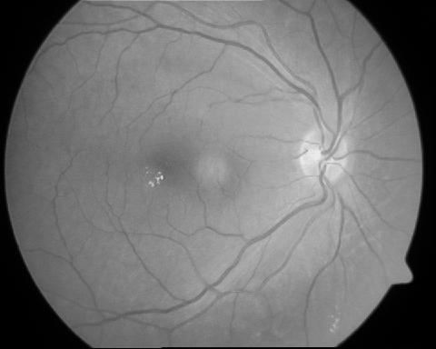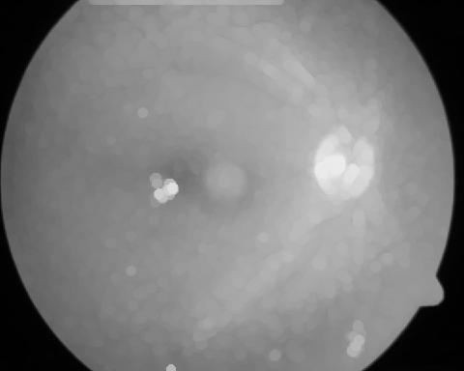

Figure 5.1a: Original image Figure 5.1b: Image after dilation with disk shaped SE

EROSION
Given sets 𝐴 and 𝐵, the erosion of 𝐴 by 𝐵, written 𝐴 ⊝ 𝐵, is defined as 𝐴 ⊝ 𝐵 =
{𝑤: 𝐵𝑤 ⊆ 𝐴}. Figure 5.2a shows an original fundus image before dilation and Figure 5.2b
shows the same image after erosion with disk shaped SE of radius 8. Blood vessels become
more prominent.

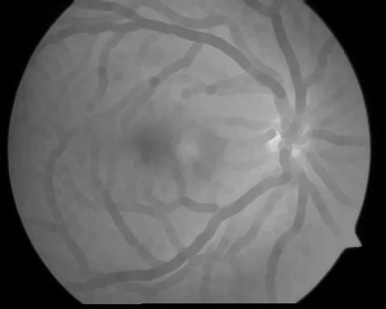

Figure 5.2a: Original image

      - Opening and Closing
Figure 5.2b: Image after erosion with
disk shaped SE

Dilation and erosion are often used in combination to implement image processing operations. Erosion followed by dilation is called an open operation. Opening of an image smoothes the contour of an object, breaks narrow isthmuses (“bridges”) and eliminates thin protrusions. Dilation followed by erosion is called a close operation. Closing of an image smoothes section of contours, fuses narrow breaks and long thin gulfs, eliminates small holes in contours and fills gaps in contours.
Opening operation of image is defined as 𝐴 ∘ 𝐵 = (𝐴 ⊖ 𝐵) ⊕ 𝐵. Since opening
operation of image consists of erosion followed by dilation, therefore it can also be defined
as 𝐴 ∘ 𝐵 =∪ {𝐵𝑤 : 𝐵𝑤 ⊆ 𝐴}.
Closing operation of image is defined as 𝐴 ∙ 𝐵 = (𝐴 ⊕ 𝐵) ⊖ 𝐵. Figure 5.3a and
Figure 5.3b shows the difference between opening operation and closing operation of
fundus images.

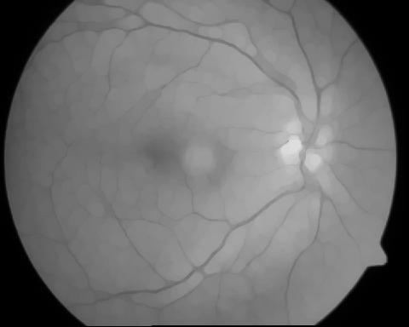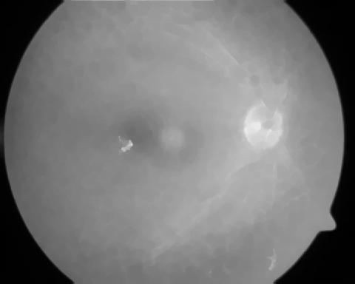

Figure 5.3a: Opening operation with
disk shaped image
Figure 5.3b: Closing operation with
disk shaped SE image

      - Edge Detection

In an image, an edge is a curve that follows a path of rapid change in image intensity. Edges are often associated with the boundaries of objects in a scene. Edge detection refers to the process of identifying and locating sharp discontinuities in an image. It is possible to use edges to measure the size of objects in an image, isolate particular objects from their background, and to recognize or classify objects.
The Canny method finds edges by looking for local maxima of the gradient of I. The gradient is calculated using the derivative of a Gaussian filter. The method uses two thresholds, to detect strong and weak edges, and includes the weak edges in the output only if they are connected to strong edges. This method is therefore less likely than the others to be fooled by noise, and more likely to detect true weak edges. The Canny method performs better than the others due to the fact that it uses two thresholds to detect strong and weak edges and for this reason, Canny algorithm is chosen for edge detection.
Figure 5.4a and b show original image and Canny edge detection methods respectively. It is apparent that by using Canny edge detection method, the weak fine blood vessels can be detected.

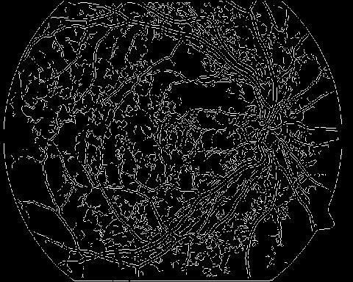

Figure 5.4a: Original image Figure 5.4b: Canny edge detected image

      - Median Filtering

Median filtering is a nonlinear operation often used in image processing to reduce "salt and pepper" noise. A median filter is more effective than convolution when the goal is to simultaneously reduce noise and preserve edges. Median of a set is the middle value when values are sorted. For even number of values, the median is the mean of the middle of two. Figure 5.5a shows an illustration of a 3 x 3 median filter for a set of sorted values to obtain the median value.

55 57 62 63 65 66 68 70 260 65
55 | 70 | 57
68 | 260 | 63
66 | 65 | 62

Figure 5.5a: Illustration of a 3 x 3 median filter

This method of obtaining the median value means that very large or very small values (noisy values) will be replaced by the value closer to its surroundings. Figure 5.5b shows

the difference before and after applying median filtering. The “salt and pepper” noise in the original image have been clearly reduced after applying the median filtering.

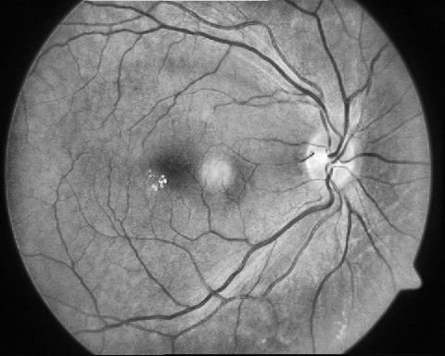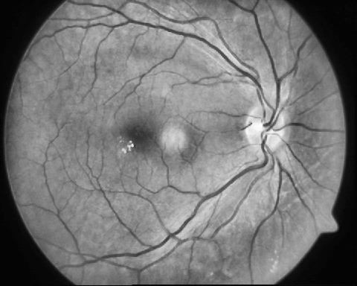

Figure 5.5b: Original image (left) and image after median filtering (right)

      - Feature Extraction Texture Analysis
Texture describes the physical structure characteristic of a material such as smoothness and coarseness. It is a spatial concept indicating what, apart from color and the level of gray, characterizes the visual homogeneity of a given zone of an image. Texture analysis of an image is the study of mutual relationship among intensity values of neighboring pixels repeated over an area larger than the size of the relationship. The main types of texture analysis are structural, statistical and spectral.
Mean, standard deviation, third moment and entropy are statistical type. Mean, standard deviation and third moment are concern with properties of individual pixels. Mean

N −1 N −1
is defined as: Mean = µ1 = ∑∑iPi, j
i=0 j=0
and standard deviation is defined as: SD = σ1 =

N −1 N −1
∑∑ Pi, j(i − μ1
i=0 j =0
)2 . Third moment is a measure of the skewness of the histogram and is

defined as: 𝜇3(𝑧) = ∑𝐿−1(𝑧𝑖 − 𝑚)3𝑝(𝑧𝑖). Entropy is a statistical type of texture that
𝑖=0
measures randomness in an image texture. An image that is perfectly flat will have entropy

of zero. Consequently, they can be compressed to a relatively small size. On the other hand, high entropy images such as an image of heavily cratered areas on the moon have a great deal of contrast from one pixel to the next and consequently cannot be compressed as much
as low entropy images. Entropy is defined as: − ∑ 𝑃 log2 𝑃. The texture features used in
this project are mean, standard deviation, third moment and entropy.

The Gray Level Co-occurrence Matrix (GLCM) method is a way of extracting second order statistical texture features. A GLCM is a matrix where the number of rows and columns is equal to the number of gray levels, G, in the image. The matrix element P (i, j |
∆x, ∆y) is the relative frequency with which two pixels, separated by a pixel distance (∆x,
∆y), occur within a given neighborhood, one with intensity ‘i’ and the other with intensity ‘j’. The matrix element P (i, j | d, ө) contains the second order statistical probability values for changes between gray levels ‘i’ and ‘j’ at a particular displacement distance d and at a particular angle (ө). Using a large number of intensity levels G implies storing a lot of temporary data, i.e. a G × G matrix for each combination of (∆x, ∆y) or (d, ө). Due to their large dimensionality, the GLCM’s are very sensitive to the size of the texture samples on which they are estimated. Thus, the number of gray levels is often reduced. GLCM matrix formulation can be explained with the example illustrated in Figure 5.6 for four different gray levels. Here one pixel offset is used (a reference pixel and its immediate neighbor). If the window is large enough, using a larger offset is possible. The top left cell will be filled with the number of times the combination 0,0 occurs, i.e. how many time within the image area a pixel with grey level 0 (neighbor pixel) falls to the right of another pixel with grey level 0(reference pixel).

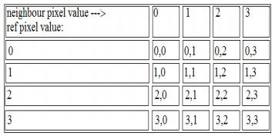

Figure 5.6 GLCM calculation

Serial No. | Function | Description
1 | retinopathy(varargin) | Gui which provides an interface for user
2 | Help.m | Pop up function describing all the steps to use the software
3 | main1(sBmp,h) | Main driver program which contains modules of segmentation and feature extraction
4 | GLCM_Features1(x,0) | Computes all the GLCM features and returns them as a structure.
5 | Feature_Extraction1(I,green_channel) | Computes all the statistical features like mean etc. and returns the same
6 | imresize(x1,[x,y]) | Resize the given image to a given resolution
7 | MA_main(x_1) | Segments the micro-aneurysm and returns the area and count.
8 | binarythining_HA(x_1) | Segments the haemorrhages and returns the area and count of these anomalies.

9 | adapthisteq(MAHA,'Atribute',value,'Atribute',value) | Applies CLAHE and returns the contrast adjusted image
10 | im2bw(med_J,thresholdvalue) | Returns the binary equivalent of the grayscale image.
11 | CoyeFil(x) | Segments the vessel structure from the fundus image.
12 | bwareaopen(binary_image,threshold) | Removes all the structures below the given threshold
13 | regionprops(labeledImage,HA) | Labels all the independent elements.
14 | RGB2Lab(im(:,:,1),im(:,:,2),im(:,:,3)) | Converts true color image to LAB color space.
15 | imsubtract(JF, J) | Subtracts two binary images and returns the difference image.
16 | graythresh(Z) | Performs otsu algorithm and returns a threshold value.
17 | imcomplement(BW2) | Performs the compliment of given binary image

18 | classifier_example(allResults,h) | Loads the training data and the testing data.
19 | wekaClassification(feature_train, class_train, feature_test, class_test, featName, classifier) | Performs the classification of the given test data against the training data.
20 | Loadarrf() | Loads the attribute related file from system for classification.

Table 5.2 Function descriptions

Table 5.2 describes the functions defined in the system. The MATLAB code for some of the functions are:

CHAPTER 6

TESTING

INTRODUCTION

Testing is a process of executing a program or application with the intent of finding the software bugs. It can also be stated as the process of validating and verifying that a software program or application or product:

- Meets the requirements that guided its design and development,
- Responds correctly to all kinds of inputs,
- Performs its functions within an acceptable time,
- is sufficiently usable,
- can be installed and run in its intended environments, and
- Achieves the general result its stakeholder’s desire.

As the number of possible tests for even simple software components is practically infinite, all software testing uses some strategy to select tests that are feasible for the available time and resources. As a result, software testing typically (but not exclusively) attempts to execute a program or application with the intent of finding software bugs (errors or other defects). The job of testing is an iterative process as when one bug is fixed, it can illuminate other, deeper bugs, or can even create new ones.
Software testing can provide objective, independent information about the quality of software and risk of its failure. Software testing can be conducted as soon as executable software (even if partially complete) exists. The overall approach to software development often determines when and how testing is conducted. For example, in a phased process, most testing occurs after system requirements have been defined and then implemented in testable programs.

Types of testing:

Black box testing – Internal system design is not considered in this type of testing. Tests are based on requirements and functionality.
White box testing – This testing is based on knowledge of the internal logic of an application’s code. Also known as Glass box Testing. Internal software and code working should be known for this type of testing. Tests are based on coverage of code statements, branches, paths, conditions.
Grey box testing – Grey-box testing (American spelling: gray-box testing) involves having knowledge of internal data structures and algorithms for purposes of designing tests, while executing those tests at the user, or black-box level. The tester is not required to have full access to the software's source code. Grey-box testing may also include reverse engineering to determine, for instance, boundary values or error messages.
Unit testing – Testing of individual software components or modules. Typically done by the programmer and not by testers, as it requires detailed knowledge of the internal program design and code may require developing test driver modules or test harnesses.
Incremental integration testing – Bottom up approach for testing i.e. continuous testing of an application as new functionality is added; Application functionality and modules should be independent enough to test separately done by programmers or by testers.
Integration testing – Testing of integrated modules to verify combined functionality after integration. Modules are typically code modules, individual applications, client and server applications on a network, etc. This type of testing is especially relevant to client/server and distributed systems.
Functional testing – This type of testing ignores the internal parts and focus on the output is as per requirement or not. Black-box type testing geared to functional requirements of an application.
System testing – Entire system is tested as per the requirements. Black-box type testing that is based on overall requirements specifications, covers all combined parts of a system.

TEST CASES

Case 1

Case name | Best Case
Input | High Quality Image (.png or .tif format)
Actual Output | Moderate
Expected Output | Moderate
Remarks | Pass

Table 6.1 Test case 1 - best case

CONCLUSION

The fast and efficient early detection of Diabetic Retinopathy is only possible if there is an effective method for segmenting the diabetic features in the fundus image. The proposed system presents a fast, effective and robust way of detecting diabetic features in the fundus images which can be used for classification of the images based on the severity of the disease. The retinal images are subjected to gray scale conversion, preprocessing and feature extraction steps. The extracted features are fed to a Random Forest classifier which will classify the images into different severity levels. Thus this Random forest technique has given a successful DR screening method which helps to detect the disease in multiple stages.

BIBLIOGRAPHY

[1] Sri, R. Manjula, M. Raghupathy Reddy, and K. M. M. Rao. "Image Processing for Identifying Different Stages of Diabetic Retinopathy." International Journal on Recent Trends in Engineering & Technology 11.1 (2014): 83.

[2] Soumya Sree, A.Rafega Beham. “BP and SVM based Diagnosis of Diabetic Retinopathy”. International Journal of Innovative Research in Computer and Communication Engineering Vol. 3, Issue 6, June 2015.

[3] Mane, Shreekant J. "Diabetic Retinopathy: Patient Identification and Measurement of the Disease Using ANN.” International Journal of Technical Research and Applications e-ISSN: 2320-8163, Issue 31(September, 2015), PP. 278-282

[4] Aravind, C., M. Ponnibala, and S. Vijayachitra. "Automatic detection of microaneurysms and Classification of diabetic retinopathy images using SVM technique." IJCA Proceedings on International conference on innovations in intelligent instrumentation, optimization and Electrical sciences ICIIIOES (11). 2013.

[5] J D Labhade , L K Chouthmol. “Diabetic Retinopathy Detection using Random Forest”. International Journal of Modern Trends in Engineering and Research e-
ISSN No.:2349-9745, Date: 28-30 April, 2016

[6] Ahmed, Mohammed Shafeeq, and B. Indira. “A SURVEY ON AUTOMATIC DETECTION OF DIABETIC RETINOPATHY”. International Journal of Computer Engineering & Technology (IJCET) Volume 6, Issue 11, Nov 2015, pp. 36-45.

[7] Jagadish Nayak, P Subbanna Bhat, Rajendra Acharya U, C M Lim, Manjunath Kagathi. “Automated Identification of Diabetic Retinopathy Stages Using Digital Fundus Images”. Journal of Medical Systems Volume 32 Issue 2, April 2008.

[8] Sopharak, M.N. Dailey, B.Uyyanonvara, S. Barman, T. Williamson, K.T. Nwe, and
Y.A. Moe, “Machine learning approach to automatic exudates detection in retinal images from diabetic Patients”, Journal of modern optics, vol.57, no. 2, pp.124-13, 2010.

[9] Gary G. Yen, and Wen Fung Leong, “A Sorting System for Hierarchical Grading of Diabetic Fundus Images: A Preliminary Study”, IEEE Transactions on Information Technology in Biomedicine, Vol. 12, No. 1, pp 118-130, January 200.

[10] James L. Kinyoun, Donald C. Martin, Wilfred Y. Fujimoto, Donna L. Leonetti. Opthalmoscopy versus Fundus Photographs for Detecting and Grading Diabetic Retinopathy. Morphology Fundamentals: Dilation and Erosion: Morphological Operations (Image Processing Toolbox™).

[11] Bernhard M. Ege et al. ―Screening for diabetic retinopathy using computer based image analysis and statistical classification, in Computer Methods and Programs in Biomedicine,Vol. 62 (2000) ,pp.165–175.

[12] Wong Li Yun, Rajendra Acharya U, Y V. Venkatesh, Caroline Chee, Lim Choo Min, E.Y.K.Ng. Identification of Different Stages Of Diabetic Retinopathy Using Retinal Optical Images. Information Sciences Vol. 178, PP 106–121, 2008.

[13] DIARET DB0 http://www.it.lut.fi/project/imageret/diaretdb1/

[14] DIARET DB1 http://www.it.lut.fi/project/imageret/diaretdb0/

[15] MESSIDOR http://www.adcis.net/en/Download-Third-Party/Messidor.html/

